The Birth of Crisis Infomatics
Because of modern media technology, the pictures and tragic news from Haiti after the January earthquakes were immediate and heartrending to watch. Leysia Palen’s research group in the Computer Science Department at CU-Boulder has been turning technology to more than just reporting. The idea takes grassroots information from those at the scene—think text messages, twitters, blogs, facebook and other Web 2.0 communication paths—to build an accurate present-time representation of the situation that can be used to direct emergency response.
Professor Palen and her graduate students are supported by a $2.8 million NSF grant along with Dr. Gloria Mark from the University of California, Irvine, and five other Boulder faculty (Ken Anderson, Dirk Grunwald, Jim Martin, Martha Palmer, and Doug Sicker) who will be familiar to computer science alumni. Recently, we talked with Palen. She pointed us to an overview of their project and kindly allowed us to pull excerpts that we thought would be of interest to you.
Please start by telling us your vision. Where will the study of crisis informatics take us in five years?
It’s Fall 2014 in Southern California. Temperatures are high and small fires have ignited in dry areas. With Santa Ana winds picking up speed and dried vegetation at its densest in years, emergency officials are worried the fires will expand and affect communities that have encroached further and further into the “wildlandurban interface.” Residents have been notified of the fires through weather and environmental alerting direct to their smart phones. Some evacuations have begun, and residents in other more distant areas remain on alert.
Upon receiving the evacuation and alert notifications, people start taking action. Most residents under evacuation prepare to leave quickly, and use smart phone applications to get information about evacuation routes and traffic conditions. But also, they post about their plans to leave; where they plan to go; as well as requests for help that they might need once they evacuate, including places to stay, medical assistance for preexisting health concerns, and help with children and pets. This information propagates to friends, family and neighbors, as well as officials who can then make better plans about who might still need evacuation assistance. Neighbors, all concerned about their communities, make plans to stay in close digital coordination to pool information they are able to gather about what is happening in their area.
Others in more distant areas are also engaged in intensified information search in case they need to evacuate quickly. They go on-line to get specific information about the fires from a wide range of peer sources that know the particular areas under threat well. After all, some areas are still rural, and require local knowledge to convey precise information about what is happening and to see what neighbors down the road are doing. Rather than attempt to assemble this online information by hand and check it against heavily taxed official websites with possibly aged information as in the past, they now have access to a suite of synthesized, easy-to-use web applications tailored to crisis situations that integrate up-to-the minute information from multiple sources. No longer must they worry about not knowing what new technology is available and missing critical information that resides in those new forums. Instead, they can readily find the most relevant online destinations and information streams with supplemental meta-information about how trustworthy, timely and relevant the information is to their particular circumstances.

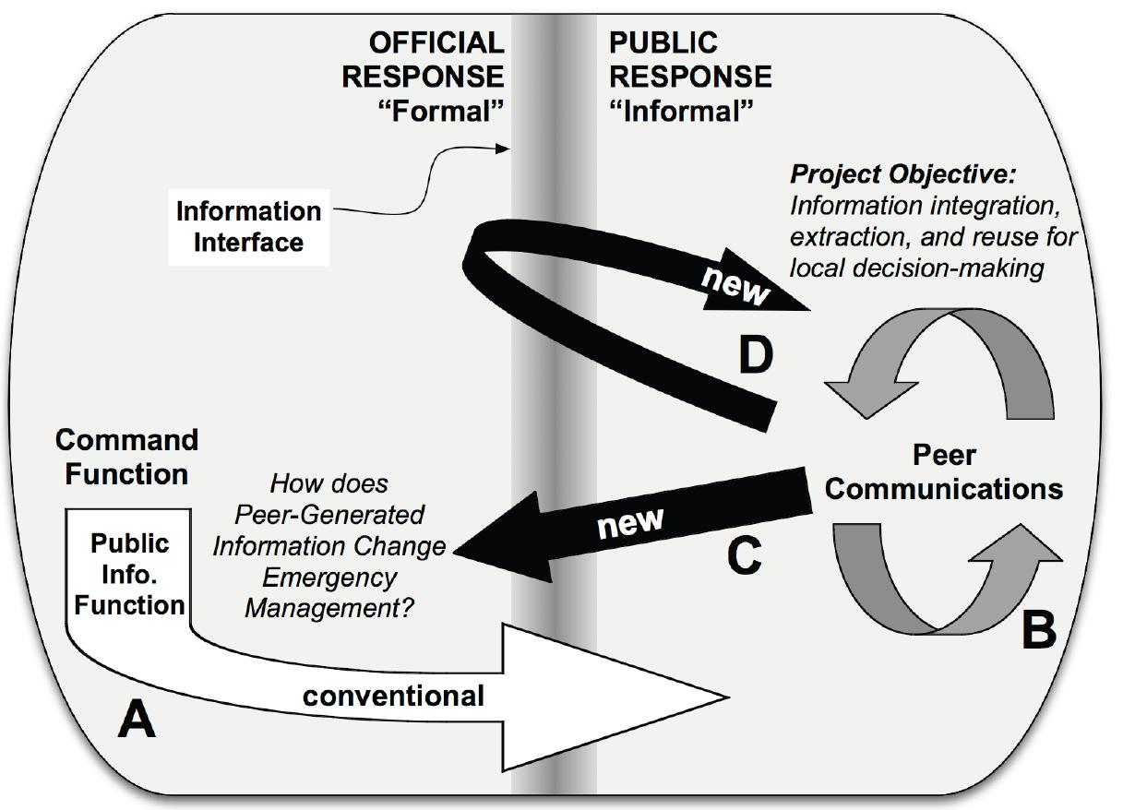
Figure 1. Crisis Response as a Social System
One figure from your paper shows your conceptualization of how the public will interact with the crisis response team? Please tell us about the new kinds of new information flow will happen.
One piece we’ve already shown in the Santa Ana scenario: More and more of the public’s information comes directly from other citizens through the information interface (arrow D in the figure). The new issue depicted by arrow C deals with the matter of where this new information is received in the organization of emergency response: Are these data that result from communications something that the “public information” function attends to, or does the “intelligence” arm of command field them? That we can ask this question speaks to the new tensions that are arising in the institution of emergency management, and is requiring it to reconsider how information is shared and received. This argument of “changing information pathways” is one we have made and presented to practitioner audiences. This issue is actively being reviewed by government agencies in the US and groups, including the US Federal Emergency Management Agency, where the new presidential appointee, Craig Fugate, is calling for increased support of such change.
In the diagram, both of the new arrows are coming from a source that might appear unreliable. How do you deal with that?
That’s the problem of the bad actor. The information we use ostensibly relies upon many users distributed within what are known as the “impact” and immediately surrounding “filter” zones communicating with mobile wireless Internet-enabled devices. But some malicious users may be injecting false information into the stream. One type of activity to detect is false information coming from a location distant from the crisis. It’s possible to verify the physical location of each contributing user using information observed by the wireless infrastructure. In several kinds of crisis situations, we can use this technique to verify
location of the information source.
Please describe some examples from the present day.
Two of our Ph.D. students, Sophia Liu amd Sarah Vieweg went to Virginia Tech in the aftermath of the tragic shootings. They could only describe the experience as harrowing, but still informative and groundbreaking for seeing the area of crisis informatics become relevant. Within 90 minutes of the shootings, before the extent of the crime was known, an I’m OK at VT group on Facebook had emerged.
Other researchers have examined examined how farmers used computational media to find information and support one another during the lengthy 2001 UK foot-and-mouth crisis. In the 2004 Indian Ocean tsunami, there were indications of significant socio-technical change in public participation behaviors such as mobile phones, personal blogging, and on-line photo repositories like Flickr. In the 2005 London terrorist attack, camera phone users on subway
trains offered officials, the media, and the public firsthand assessments of the impact of the bombings. After the May 12, 2008 Sichuan earthquake in China, a popular internet forum became a location for integrating information with other people from multiple sources, organizing public action and expressing grief and anger.
Work in the area of humanitarian crisis, specifically the Kenyan postelection violence in January 2008, was the basis for the creation of a “crowd sourcing” environment, “Ushahidi,” where people could warn of and report violence. Initial findings on an analysis of the use of that system show that citizen journalism had a greater geographical reach than traditional sources.
Last year more examples emerged. During the floods of the Red River of the North during the Oklahoma grassfires, we did extensive research of twitter records, examining the relationship between geographical location and the generation of new information. Analysis of the “neogeographers” who emerged during these events to create crisis map mashups reveals the relationship between design decisions and mashup evolution (Liu & Palen 2010).
In the area of public health, disease trajectories are being tracked and anticipated through Internet search. Multiple efforts, including Google Flutrends, track flu outbreaks by analyzing and geolocating relevant query terms (e.g., “aches”). The US Geological Association uses citizen geo-reports to measure the intensity of earthquakes on “Did You Feel It” (earthquake.usgs.gov/eqcenter/dyfi/). They have also deployed software using common accelerometer-based laptops to detect earthquakes, and are now mining twitter for earthquake detection. This again suggests a future vision of computer-augmented
users as participatory data collectors.

What are some of the specific questions that you’ll be analyzing as part of your NSF research?

In tackling such empirical goals for disaster research, we must understand features of activity at different
scales of interaction. This includes (but is not limited to) analysis of:
- where and when online crisis-based information arises;
- how people organize around online information exchange including the degrees and types of participation;
- who participates and why;
- the presence or absence of self-policing for accuracy and credibility;
- the management of timeliness of information;
- the kind of information needs that arise for different kinds of large-scale emergencyevents, and who needs what kinds;
- how people make judgments about the accuracy/validity of information from peers.

Thank you for your time, Leysia, and for allowing us to pull these excerpts from your work. Best of luck in your group’s continued research.

